**Project Planning Phase**

**Project Planning Template (Product Backlog, Sprint Planning, Stories, Story points)**

|  |  |
| --- | --- |
| Date | 16 June 2025 |
| Team ID | LTVIP2025TMID32454 |
| Project Name | Clean Tech:Transforming Waste Management with Transfer learning |
| Maximum Marks | 5 Marks |

**Product Backlog, Sprint Schedule, and Estimation (4 Marks)**

Use the below template to create product backlog and sprint schedule

| **Sprint** | **Functional Requirement (Epic)** | **User Story Number** | **User Story / Task** | **Story Points** | **Priority** |
| --- | --- | --- | --- | --- | --- |
| Sprint-1 | Dataset & Model Setup | USN-1 | As a developer, I can collect and label municipal waste image datasets for model training. | 5 | High |
| Sprint-1 | Dataset & Model Setup | USN-2 | As a developer, I can preprocess images (resizing, augmentation, normalization) before training. | 3 | High |
| Sprint-2 | Model Training | USN-3 | As a developer, I can fine-tune a pre-trained model (e.g., ResNet50) using the waste dataset. | 5 | High |
| Sprint-2 | Model Integration | USN-4 | As a system engineer, I can deploy the trained model into a real-time image classification pipeline. | 5 | High |
| Sprint-3 | System Design | USN-5 | As a developer, I can design architecture for real-time image capture from cameras. | 3 | Medium |
| Sprint-3 | Waste Category Mapping | USN-6 | As a developer, I can define logic to classify waste into recyclable, organic, general, and hazardous categories. | 2 | Medium |
| Sprint-4 | Interface & Dashboard | USN-7 | As a user, I can view classification results and waste statistics on a simple dashboard. | 3 | Medium |
| Sprint-4 | Notification System | USN-8 | As a system, I can trigger alerts or commands to sorting arms or city systems based on waste type. | 4 | High |

**Project Tracker, Velocity & Burndown Chart: (4 Marks)**

| **Sprint** | **Total Story Points** | **Duration** | **Sprint Start Date** | **Sprint End Date (Planned)** | **Story Points Completed (as on Planned End Date)** | **Sprint Release Date (Actual)** |
| --- | --- | --- | --- | --- | --- | --- |
| Sprint-1 | 20 | 6 Days | 01 June 2025 | 06 July 2025 | 13 | 06 July 2025 |
| Sprint-2 | 20 | 6 Days | 07 June 2025 | 12 July 2025 | 10 | 12 July 2025 |
| Sprint-3 | 20 | 6 Days | 14 June 2025 | 19 July 2025 | 11 | 19 July 2025 |
| Sprint-4 | 20 | 6 Days | 21 June 2025 | 26 July 2025 | 8 | 26 July 2025 |
|  |  |  |  |  |  |  |
|  |  |  |  |  |  |  |
|  |  |  |  |  |  |  |
|  |  |  |  |  |  |  |

**Velocity:**

Imagine we have a 24-day sprint duration, and the velocity of the team is 42 (points per sprint). Let’s calculate the team’s average velocity (AV) per iteration unit (story points per day)

AV=sprint duration/velocity=42/24=1.75

**Burndown Chart:**

A burn down chart is a graphical representation of work left to do versus time. It is often used in agile[software development](https://www.visual-paradigm.com/scrum/what-is-agile-software-development/) methodologies such as [Scrum](https://www.visual-paradigm.com/scrum/scrum-in-3-minutes/). However, burn down charts can be applied to any project containing measurable progress over time.

[**https://www.visual-paradigm.com/scrum/scrum-burndown-chart/**](https://www.visual-paradigm.com/scrum/scrum-burndown-chart/)

[**https://www.atlassian.com/agile/tutorials/burndown-charts**](https://www.atlassian.com/agile/tutorials/burndown-charts)

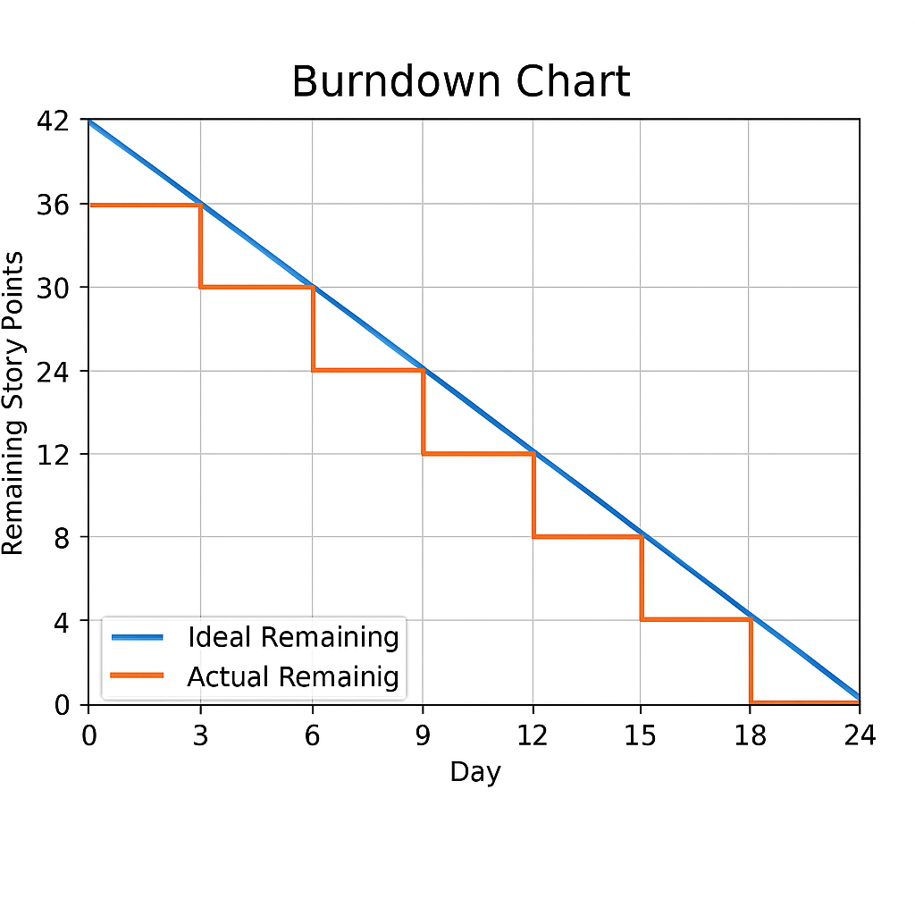

**Reference:**

[**https://www.atlassian.com/agile/project-management**](https://www.atlassian.com/agile/project-management)

[**https://www.atlassian.com/agile/tutorials/how-to-do-scrum-with-jira-software**](https://www.atlassian.com/agile/tutorials/how-to-do-scrum-with-jira-software)

[**https://www.atlassian.com/agile/tutorials/epics**](https://www.atlassian.com/agile/tutorials/epics)

[**https://www.atlassian.com/agile/tutorials/sprints**](https://www.atlassian.com/agile/tutorials/sprints)

[**https://www.atlassian.com/agile/project-management/estimation**](https://www.atlassian.com/agile/project-management/estimation)

[**https://www.atlassian.com/agile/tutorials/burndown-charts**](https://www.atlassian.com/agile/tutorials/burndown-charts)